Domaine Systèmes Autonomes – DSAT301 Systèmes Embarqués

Specification of the functional and physical architecture
in SysML with Catia Magic (ex. Cameo Systems Modeler)
Quentin Cespèdes, Janette Cardoso, Mayssa Chebi, Mourad Chibane,

Introduction
Objectives of the exercise:
- Use SysML modeling for designing an autonomous drone system
- Practice SysML modeling in an industrial tool: Catia Magic System of Systems Architect (ex. Cameo Systems Modeler). The text uses the shorthand Cameo to refer to the tool.
Among the 9 SysML diagrams, you will have to handle 4 diagrams: the use case diagram, the sequence diagram, the activity diagram and the internal block diagram. We will focus on the Operational Analysis, Functional Analysis, Physical Analysis stages, according to a simplified version of the method used by Samares Engineering.
Remarks:
- During this exercise, our “System of Interest” (SoI) is a drone which can follow a flight plan autonomously. Thus, the "Ground Station" is not part of our scope of study for the moment.
- The menus are sometimes in English in the text, and in French in the CAMEO software. This text uses Cameo, you can replace it with Magic CSE.
Useful information on Cameo and the model:
- To start the tool: in Windows, open the Catia Magic "Systems of Systems Architect" application Choose "Defaults". -- Select "Use a floating license": the server name is licence-w2k19.isae.fr and the port number is 1101.
- When starting the tool, choose the “Systems Engineer” Perspective, the SYSML icon (see fig.) and tick Expert. You can also do it later after load the model from the menu Options -> Perspectives, then choose System Engineer (courant) and tick Expert.
- To switch Cameo to English: choose Options > Environment, type "lang" in the search field, then choose English.
- To install the OMF-ISAE plugin: download the plugin with the button in the guide. In Cameo, choose Help > Resource & Plugin Manager, click Import and select the plugin file. Then restart MagicDraw (Cameo): the plugin is only loaded at startup.
- To load the model: Download the model from LMS, or from the guide with its download button, and do not unzip it. From Cameo menu, "Open the project" (choose UAV_BE_Note_2024 _V2_Exercice Student.mdzip).
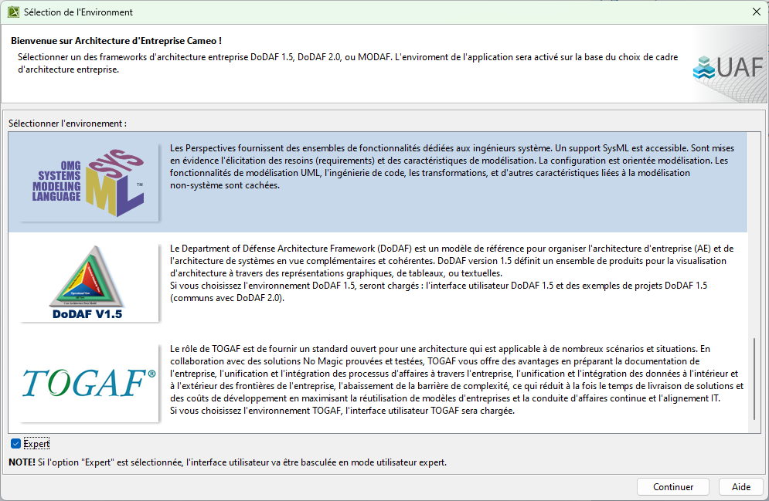

- As with most MBSE tools, you have a model browser (left) and different diagram views (center). Remark: in general, deleting an element from a view does not delete it from the model; to completely delete a model element, do it from the browser (it will also delete it from all views).
- Edit properties of a model element – ​​3 solutions:
  - Double click on a diagram element / model element. Note: if another diagram opens, use one of the other following two methods.
  - Click on a diagram element / model element then Enter
  - Right-click on a diagram element / model element then Specification
- Switch to "Expert" mode: at the top right of the specification dialog for an element, in the "Properties" field on top right, choose "Expert" (see figure below). This gives access to more properties of the element to specify.

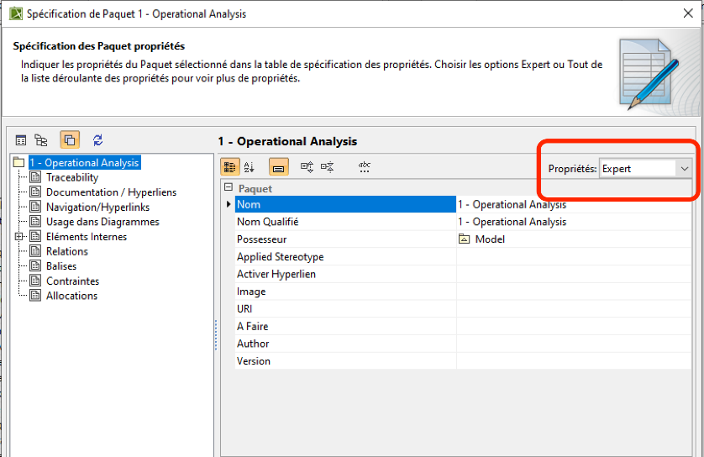
Figure . Element specification - Expert mode

Discover the model
This model is composed of different packages, in which the different model elements are stored according to the level of modeling. Here we have only 3 levels: Operational, Functional, and Physical architecture.
No description of the SoI is given on purpose: read the model yourself, and be able to explain the main aspects of the drone through it. Each of the three levels answers a different question:
Operational (OP): the context, the use cases and the scenarios. They set the scope of the system and the mission it serves.
Functional (FCT): the state machine that orchestrates the activities. It shows how the drone carries out its mission, step by step.
Physical: the block and internal block diagrams (BDD/IBD) of the physical product chosen for the solution.
A good starting place is the operational context diagram; you’ll find it in "1 – Operational Analysis / B – Operational Breakdown / Operational Context / Operational Context”. The context diagram is an internal block diagram (IBD). This diagram represents the connections between the environment and the drone. Look at the Item Flows (the physical flows) on the different connectors (UAV-ground station, UAV GNSS, etc). We can see that the number of connections between the operator and the drone is very limited: start or stop the drone. Indeed, the system must be autonomous, the connections between the operator and the drone are minimized. Double-click on the UAV icon to see its internal block diagram; click on the arrow on the toolbar at the top left of the diagram to go back.
Continue exploring the whole model.

The mission

According to a given flight plan, your system shall first join the predefined safe zone, then start patrolling around its perimeter until the end of the mission. During this patrol, the system shall track the sheep. If one goes outside the safe zone, it shall notify the Shepherd and continue patrolling.

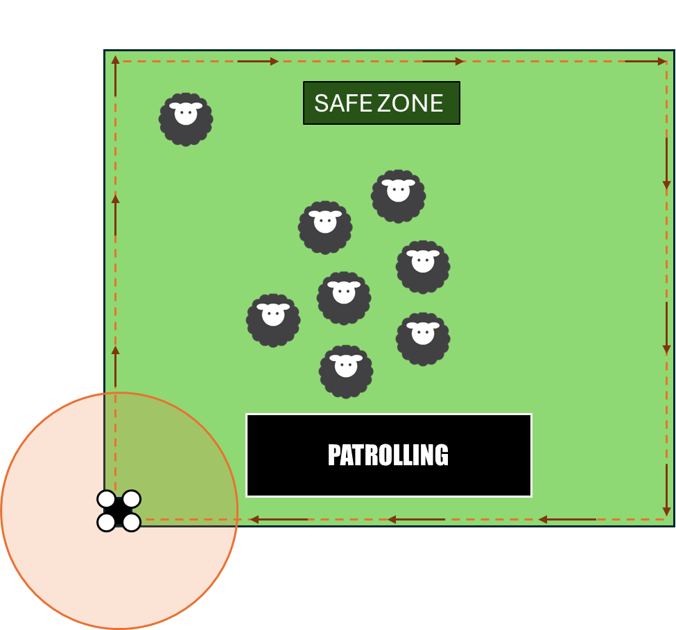

Guided exercise: add a function to the SoI

Associate a Sequence Diagram to a Use Case
In "Model Browser": Model/ 1- Operational Analysis/ A – Use Cases and Scenarios/ Use Cases and Scenarios. Locate the Parameter Mission, Surveillance of a "safe zone" area use cases and Monitor sheep position. We will then work on Use Case Parameter Mission.
We are now going to enter a scenario that allows us to initialize the drone with a flight plan using a sequence diagram.
“Parameter Mission” scenario: “The operator start the SOI using the ground station, then still using the ground station he sends the flight plan to the SOI-drone. The ground station sends the flight plan to the drone by WiFi. The drone loads the flight plan into memory and checks the perimeter of the flight plan. Upon successful loading, the ground station receives a notification, and the operator is informed that the mission is ready to start.
- Go to Operational Analysis / C – Use Cases and Scenarios” open the “Use Cases and Scenarios” diagram.
- Open the “1. Preparation phase” Package by clicking on +.
- Locate the Prepare Mission use case in the diagram.
- Identify the “Parameter Mission” use case.
- Right-click on this use case then “Create Diagram” and Here’s the translation: and in the "SysML Diagrams" section select “SysML Sequence Diagram” ( are no results in the diagram types list, click the Expert button below it. The list of available diagrams expands in the Expert mode.).
- Rename it “[SD1] Loading Flight Plan success”, SD for Sunny Day (nominal scenario, i.e., everything is OK), RD for Rainy Day (disfunctional scenario, i.e., something went wrong).
- Let's first add the lifelines from the actors already created in “1 – Operat. Analysis / A – Use Cases and Scenario” (see figure 2).
- From 1-A-Actors, add the actors “Mission Operator” and “Ground Station” on the diagram by dragging and dropping from the Model Browser
- Our drone is missing... It is found in “3 – Physical Analysis / A – Physical Architecture: “SOI - Pasture Sentinel”. Add the drone as a lifeline by dragging and dropping from the Model Browser.
- Add the messages exchanged between these 3 actors. (Stop the arrow when a blue vertical line appear line the time line of the actor). The resulting scenario should look like the figure below. Please use only the "Send Message" and "Message to Self" type elements from the palette (or click on the lifeline).
  - For Messages to Self, give the following names: Load FlightPlan and Check FlightPlan Perimeter.
  - For "Send Message" (incoming or outgoing): it can be associated with a functional signal. You can create a new signal by clicking on the S button next to the message name, use the auto-completion to select an existing signal, or drag and drop an existing signal from 2 - Functional Analysis / B - Functional Data / Deployement onto the message.
  - Organize the signals you created in the Functional Data package 2 - Functional Analysis / B - Functional Data / Deployement.
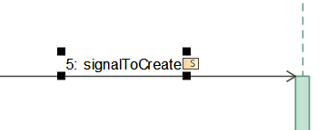
Click on the S button to create a signal for the message.
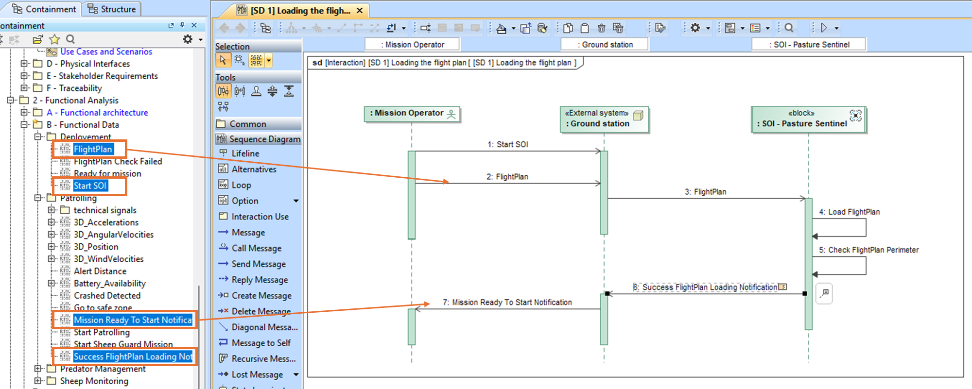
Figure . Sequence Diagram for our use case

The same scenario, one message at a time
Question 1 : What is the type of this sequence diagram?
□ - Black-Box □ - White-Box
Justify. ………………………………………………………………………………………………

Adding functions
The sequence diagram that we have just created has allowed us to identify new functions which will be modeled by Activity Diagrams (DA).
Question 2: From the "[SD 1] Loading the flight plan" scenario modeled by the Sequence Diagram of Figure 2, and from what has been seen in progress, list here the 4 new functions of SOI - Pasture Sentinel.
Justify.………………………………………………………………………………………………………
The functional architecture is in “2 – Functional Analysis / A – Functional Architecture” (click on the + to the left of the icon). We represent functions as SysML activities.

B.1 Adding a function (or activity)
- Open the "2 - Functional Analysis" -> “A - Functional architecture” package by clicking on the small + to the left of the icon.
- This package is meant to store functions (Activity), it can be organized using sub packages. One way to structure it is to organize your function around a Service (guard the sheep, configuration, Mission Monitoring, etc.).
To add a function : Right Click on the package “Deployment”, “create element”, “Activity”.
- A new function appears in the tree (in the containment tree): name it "Parameter Mission". This function represents the use case we specified with the "Parameter Mission".
- Create a package “Parameter Mission” under Deployment, and move the function inside.

Exercise: Still in the Containment Tree: Add the 4 functions identified in question 2, by creating 4 activities, in the “Parameter Mission” sub-package.

State Machine Diagram

C.1 Complete State Machine to pilot the activity triggering
In this exercise, you will complete an existing state machine describing the functional behavior of the system, by configuring specific states and transitions. The goal is twofold: to understand what is a state machine, and how to add and label states, allocate signals to transitions, and assign activities within a state.
GOAL: Update the state machine so that it covers the whole mission, and allocate each function to the state where it runs. You allocate Load Flight Plan to the state “Configured” as a “Do activity”.
- Allocate the signal on the transition (Flight plan, Flight plan check successful, ready for mission)
- Then complete the load flight plan function (same kind of exercise as before)
Which function runs in which step:
- Configured (load the flight plan and check it): runs Load Flight Plan. You allocate it in this chapter.
- Ready for Mission: runs Start subsystems.
- Going to Safe Area (join the safe zone): runs Going to Safe Area.
- Patrolling (patrol the perimeter and track the sheep): runs Watch Perimeter and Sheep monitoring, side by side.
- Predator Detected: runs Start Predator Tracking, then Trigger predator counter actions.
- Crashed: runs Start Emergency Mode.
- Predator Monitoring and Mission Monitoring have no function of their own.
Steps
In the containment tree go to 3- Physical Analysis / A- Physical architecture / SOI-pasture Sentinel --> open this state machine diagram 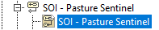
Create a new state “Configured” inside state “Undeployed”
- In the palette, click on State. Then, go to the diagram, right-click next to the “Unconfigured” State, and a new Unnamed State will be created.
- Type “Configured” directly on the shape of that state and press Enter.
Allocate signals to transition
- Left-click on the “UnConfigured” state and click the Transition button on its smart manipulator toolbar and drag it to ”Configured” state.
The signal is the trigger of the transition. Reuse a signal already described in the scenarios or in the function descriptions: it states the condition under which the transition fires. Reformulate it if needed, so that it reads as a short condition.
- In the Model Browser, expand the contents of the following packages: 2 Functional Analysis > B Functional Data > Deployment.
- Select the “FlightPlan” signal and drag it to the transition between the “Unconfigured” and ‘Configured” states
- Select the shape of the “Configured” state and click the Transition button on its smart manipulator toolbar and right click on ”Unconfigured” sate.
- Select the “FlightPlan Check Failed” signal and drag it to the transition between the “Configured” and ‘Unconfigured” states
- Select the shape of the “Configured” state and click the Transition button on its smart manipulator toolbar and right click on ”Ready for Mission state”.
- Select the “Ready for mission” signal and drag it to the transition between the “Configured” and “Ready for Mission” states
Allocate “Load Flight plan” function added in Exercise B to “Configured” state:
- In the Model Browser, expand the contents of the following package: 2 Functional Analysis > A Functional architecture > Deployment.
- Select the “Load Flight Plan” activity in the Model Browser, drag it onto the “Configured” state and select “Do Activity”.
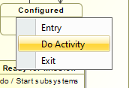
When you’re done, your state machine diagram should be very similar to the one in the figure below.
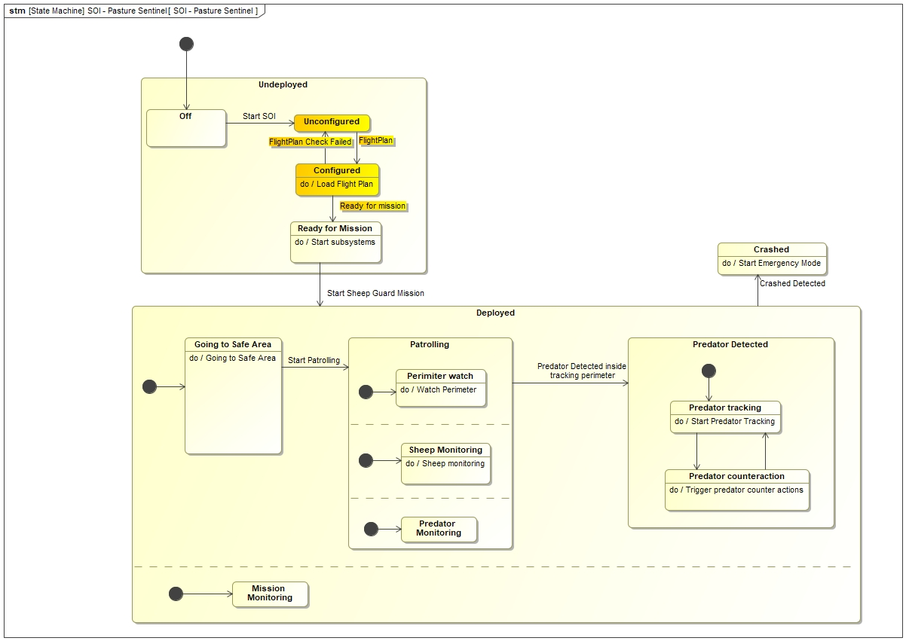

C.2 Run the state machine simulation
To start the execution, click the Run button in the toolbar above
- Make sure the state machine under SOI-Pasture sentinel is open (3-A-SOI-SOI-SOI)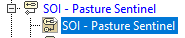
- Click on simulate, then click on the Simulation icon on the right top of Diagram, “Run”. 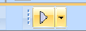
- At the simulation window (the botton of the main window), click on the Play button (green arrow) at its left top. You can speed up or slow down the animation with the “Animation Speed” slider. 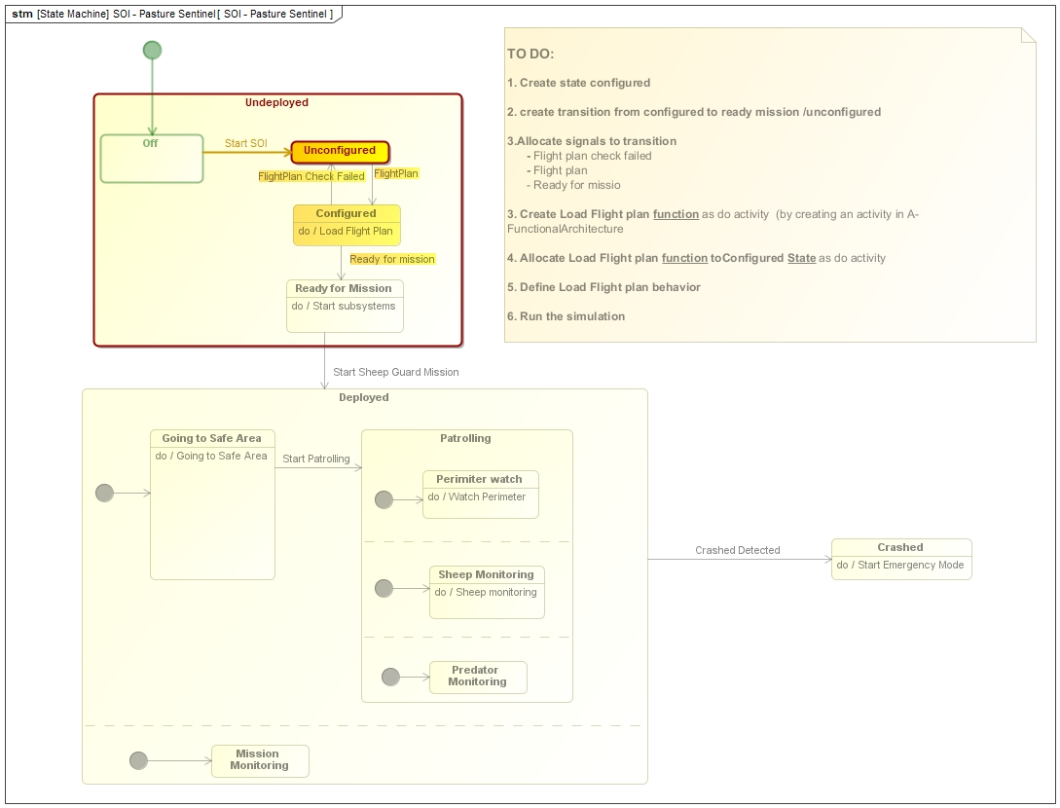
- In the Simulation panel, select your signal trigger to advance the simulation and transition from one state to another as shown in the figure below.
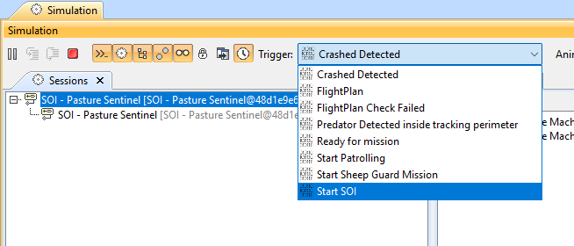

C. 3 Run the cross diagram simulation by triggering the simulation from the state

Follow again the step 1 from section C.2 for starting a simulation.
Inside the State Machine diagram, double click on the “Do Load flight plan” label (in state Configured): the Activity Diagram of this function appear (as in Fig. 7).
For seeing the cross diagram simulation (State Machine SM and Activity Diagram AD) open both diagram in different tabs.
Start the simulation again following the steps 2 to 4 from section C.2. When arriving at state Configured, the AD will also be simulated (a red token appear in the AD when the SM arrives at this state).

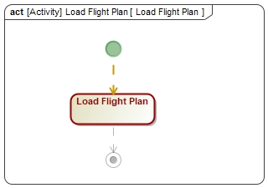
Figure . Simulation of an Activity Diagram (DA)

Define the function "Load Flight Plan"

Specification: If the flight plan loading succeed we shall send a “Ready for mission” signal, which will allow to leave the “Configured” state for the “Ready for mission” state. In parallel we also want to notify the Control Operator with a Activity Diagram as described in the “Parameter Mission” scenario (section A).

The functional data "FlightPlan" comes from the ground station via WiFi. This data is produced by one of the functions identified in question 2. All the functions required have already been created in the Step “B.1. Adding a function”. All functional data can be found in 2 – B Functional Data – Deployement.
Remark: A Sequence Diagram describe only one scenario, for example, “The plan was successfully loaded” (Sunny Day, cf pg 3). However, an Activity Diagram is supposed to represent all the possible scenarios. In this case, also the scenario “The plan was not successfully loaded” (Rainy Day, cf pg 3).
- In the Model Browser: right-click on the "Load Flight Plan" function in Model/ 2-Funct. Analysis / A – Function. Archi / Deployment / Parameter Mission (package )
- Click on “Create Diagram” then choose “Activity Diagram”. If a window opens asking to display the parameters, click on “Ok”.
- You have already created some functions in section B.1. You can drag and drop the functions related to "Load Flight Plan" function inside the Activity Diagram (anywhere). You may also create new ones if you think it necessary, then drag and drop them in the AD.
General instructions for connecting the functions in an Activity Diagram:
- To represent the send signal, drag and drop the according signal anywhere in the diagram, or create a “Send Signal Action” then drag and drop the signal on the diagram and type it (give a type).
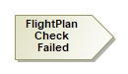
- To represent a decision, use a decision node from the icons on the left of the AD. Add the guard on output flow (ex: “wind > 50km/h”, “else”). Guard can be defined by renaming the flow in the diagram, putting the condition between brackets (“[wind > 50km/h]”)
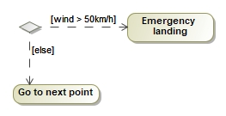
Example of decision node

- To represent the parallelism use a fork node (which splits a flow into multiple concurrent flows).
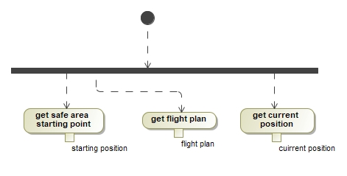
Example of fork node

Let us consider the scenario Rainy Day (pg 3) as “[RD 1] Flight plan out of range”, if the flight plan loading fail, the system need to send a “FlightPlan Check Failed”.
You can simulate the Activity Diagram, for ensuring the right behavior. Make sure the animation covers all elements.
What to check: Make sure the animation covers all elements. You will notice that checking if everything is covered can become laborious, hence the need for automatic verification tools and formalisms such as Petri nets.

D.1. Simulate the State machine to ensure the right implementation

- Go back to SOI – Pasture Sentinel State machine, (3-A-SOI-SOI-SOI)
- Start the simulation using 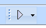 then 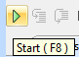

- Use the Trigger drop list to switch from state to state

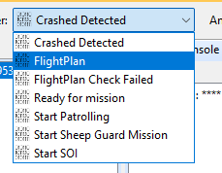
- Verity that after entering “Configured” state, your activity diagram is triggered, and if the flight plan is OK, it shall automatically go to Ready for Mission

Take a few minutes to observe what is happening during the crossing simulation of the State machine and understand the execution semantics of the functional architecture seen in progress (similar to Petri nets): function start condition, end condition execution of a function. Enter the functions by double-clicking on the function calls. You can go back by clicking on the small left and right arrows at the top left of the diagram.

Tips: you can drag an drop the activity diagram in the state machine to monitor both during the simulation. After drag and drop, select the diagram and click on the “eye” to show its content.
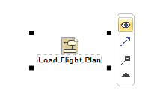
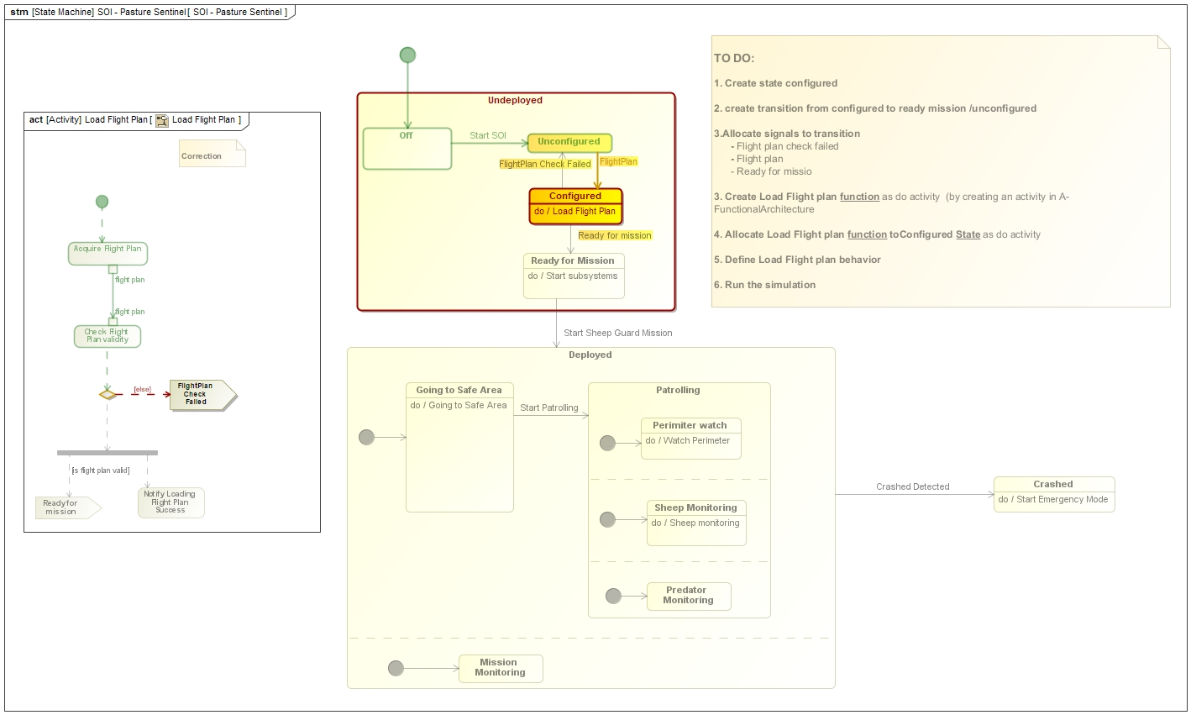

Updating function allocations on the subsystems
We are going to fill the allocation matrix available under “2 – Functional Analysis / C – Traceability”.
The physical architecture of the subsystems can be seen under “3 – Physical Analysis / A – Physical Architecture / SOI – Pasture Sentinel”. Notice the two diagrams: UAV Data and UAV Energy. These two diagrams show two different views of the same model: the electrical (physical) view and the data (cyber) view.
Complete the “Function Allocation” allocation diagram (2 - C) so that the 3 functions created previously are allocated to a subsystem. Tip: two functions are allocated to the navigation system and one function is allocated to the WiFi system.
The allocation allows us to do an impact analysis (which we won't see here). This impact analysis allows us to know the elements that are impacted when we CRUD (Create / Read / Update / Delete) model elements in order to verify and validate that the model still represents the correct system.

FAQ
- In the sequence diagram exercise, how do you use the messages to name functions?
Answer: In this Seminar we do not exploit the traceability between the messages in the SD and the name of the functions in the Activity Diagram. It is up to the user to maintain consistency between these elements.

- The state machine exercise uses FlightPlan (2.B Functional Data) and the sequence diagram exercise used Wifi_FlightPlan (1.C Physical Flows). What is the difference?
Answer: The functional flow is the business concept and focuses on the goal (stop signal, energy, insecticide product), and the physical flow which is the solution chosen to achieve it (electric current 5mv, electric current 240v, ...). The Flight Plan from a functional point of view is a list of positions, but we know neither the format, nor the encoding, nor theoretically the means of communication. The physical flow is characterized data, we are talking about a 12 volt, 100ma voltage, with a given frequency, or a signal transmitted by UDP frame every 500 ms.

- How to insert a breakpoint for the simulation?
Answer: right click on the function in the diagram then Simulation -> Add Breakpoint

- Is the context diagram a SysML diagram?
Answer: The block diagram is used to represent the operational context of the system. We then speak of a context diagram which uses the SysML notation. A block diagram can be used to outline architecture in a context diagram, to structure functions, or to describe a design. In the 3 cases we use a SysML diagram without creating, syntactically speaking, a deviation from SysML (which remains a notation).

